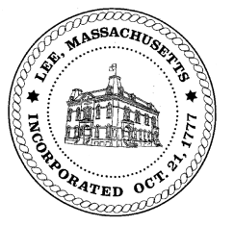
TOWN OF LEE
BOARD OF PUBLIC WORKS

Meeting Notice

Date: Tuesday, September 3, 2019 Time: 4:30 PM Place: 45 Railroad St., Lee

Agenda
Water
- Meter update
Highway/Cemetery
- Paving – Maple Streets bids
Waste Water
Other
- 1520 Pleasant/Hunt/billing
- 41 Robert Street/Barrett/re: Cliff Street
Abatements
- 115 Theresa Terrrace/pool
- 45 West Pine/meter
- 10 Harwood Drive/pool

Approve Minutes from August 13 2019 And any topic the chairman could not reasonably anticipate.
Next Board Meeting September 24, 2019
BPW Members: Robert Bartini-Chairman, David Forrest-Clerk, Roger Scheurer, Peter Scolforo, Donald Zukowski,, Christopher Ketchen (Non Voting Member)

