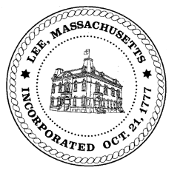
TOWN OF LEE
BOARD OF PUBLIC WORKS

Meeting Notice

Date: Tuesday, September 24, 2019 Time: 4:30 PM Place: 45 Railroad St., Lee

Agenda
Water
- Meter update
- Discussion business capacity fees
Highway/Cemetery
- Paving – Maple Street update
- Surplus Equipment bid update
Waste Water
Other
Abatements
- 1590 Pleasant Street

Approve Minutes from September 3, 2019 And any topic the chairman could not reasonably anticipate.
Next Board Meeting October 8, 2019
BPW Members: Robert Bartini-Chairman, David Forrest-Clerk, Roger Scheurer, Peter Scolforo, Donald Zukowski,, Christopher Ketchen (Non Voting Member)

