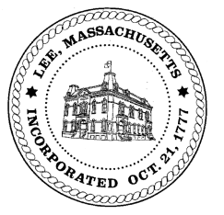
TOWN OF LEE
BOARD OF PUBLIC WORKS

Meeting Notice

Date: Thursday, September 16, 2021 Time: 10:00 AM Place: 45 Railroad St., Lee

Water
- Meter update
Highway/Cemetery
- Capital
- Paving for phase 1 water line
- Additional paving FY22
Waste Water
- None
Other
- Sign Abatements & Commitments
- Curb Cut 305 Church Street - Chittenden
Abatements
- 100 Mountainview Terrace

And any topic the chairman could not reasonably anticipate.

BPW Members: Robert Bartini-Chairman, David Forrest-Clerk, Roger Scheurer, Peter Scolforo, Donald Zukowski, Gary O’Brien, Christopher Ketchen (Non Voting Member)

