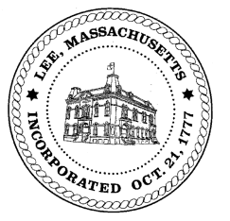
TOWN OF LEE
BOARD OF PUBLIC WORKS

Meeting Notice

Date: September 13, 2016 Time: 4:30 PM Place: 45 Railroad St., Lee

Agenda
Commitments
- Misc Commitments
Abatements
- Review abatement language & form
- Misc Application
Water
- None
Highway/Cemetery
- Crosswalks
- Paving 2016
- Forest Street
- Truck/Equipment
Waste Water
- None
Other
- None

Approve Minutes from July 26, 2016.& August 30, 2016
And any topic the Chairman could not reasonably anticipate.
Next Board Meeting: September 27, 2016
BPW Members: Robert Bartini-Chairman, David Forrest-Clerk, Roger Scheurer, Peter Scolforo, Donald Zukowski, Jonathan Terry, and Robert Nason (Non-voting member)

