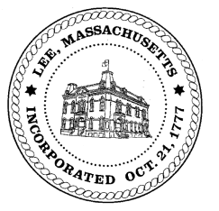
TOWN OF LEE
BOARD OF PUBLIC WORKS

Meeting Notice

Date: Wednesday, August 12, 2020 Time: 3:30 PM Place: 45 Railroad St., Lee

Water
- Meter update
- Water line update – Phase 1: Reservoir Road to Mill.
Highway/Cemetery
- Highway Supervisor and Truck Driver Positions
Waste Water
- None
Other
- Abatements & Commitments
Abatements
- 120 Summer Street – Donahue
- 41 Prospect Street – Lucy pool
- 348 Bradley – Tremblay pool

Approve Minutes from July 8, 2020 And any topic the chairman could not reasonably anticipate.
Next Board Meeting: August 26, 2020
BPW Members: Robert Bartini-Chairman, David Forrest-Clerk, Roger Scheurer, Peter Scolforo, Donald Zukowski, Christopher Ketchen (Non Voting Member)

