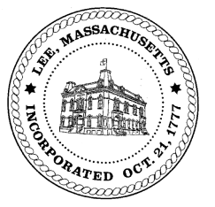
TOWN OF LEE
BOARD OF PUBLIC WORKS

Meeting Notice

Date: Wednesday, July 8, 2020 Time: 3:30 PM Place: 45 Railroad St., Lee

Water
- Meter update
- Water line update – Phase 1: Reservoir Road to Mill.
Highway/Cemetery
- Foundation rates
Waste Water
- Green Theory Cultivation – sewer discharge
Other
- 50 Columbia drainage – Naventi update
- 100 Church – Baumann - drainage
- 820 Greylock – MacDowell- drainage
- CDG Properties – 156 West Park – water line
- 170 Prospect – updated numbers
Abatements
- 120 Summer Street – Donahue
- 666 East Street - pool
Approve Minutes from June 10, 2020 And any topic the chairman could not reasonably anticipate.
Next Board Meeting: July 14, 2020
BPW Members: Robert Bartini-Chairman, David Forrest-Clerk, Roger Scheurer, Peter Scolforo, Donald Zukowski, Christopher Ketchen (Non Voting Member)

