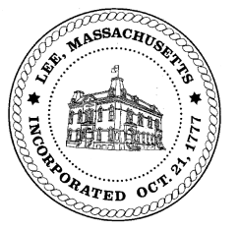

**TOWN OF LEE**

**BOARD OF PUBLIC WORKS**

***Meeting Notice***

**Date:** July 26, 2016 **Time:** 4:30 PM **Place:** 45 Railroad St., Lee

***Agenda***

**Commitments**

* Water/Sewer July Quarter

**Abatements**

* Misc Adjustments

**Water**

* Estimate List

**Highway/Cemetery**

* Large Truck discussion
* Paving

**Waste Water**

* None

**Other**

* Capacity Fees
* Personnel Turnover

Approve Minutes from *June 28, 2016.*

**And any topic the Chairman could not reasonably anticipate.**

Next Board Meeting: ***Aug 09, 2016***

*BPW Members: Robert Bartini-Chairman, David Forrest-Clerk, Roger Scheurer, Peter Scolforo, Donald Zukowski, Jonathan Terry, and Robert Nason (Non-voting member)*