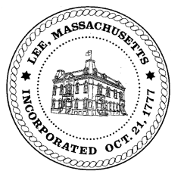
TOWN OF LEE
BOARD OF PUBLIC WORKS

Meeting Notice

Date: Tuesday, July 23, 2019 Time: 4:30 PM Place: 45 Railroad St., Lee

Agenda
Water
- Meter update
Highway/Cemetery
- Paving
Waste Water
- 131 Paul Drive/sewer hook-up
Other
- 335 Church – curb cut extension – remove per resident
Abatements

Approve Minutes from June 25, 2019 And any topic the chairman could not reasonably anticipate.
Next Board Meeting August 13, 2019
BPW Members: Robert Bartini-Chairman, David Forrest-Clerk, Roger Scheurer, Peter Scolforo, Donald Zukowski,, Christopher Ketchen (Non Voting Member)

