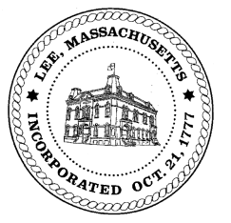
TOWN OF LEE
BOARD OF PUBLIC WORKS

Meeting Notice

Date: Tuesday, July 20, 2021 Time: 4:00 PM Place: 45 Railroad St., Lee

Water
- Meter update
- Water line request Robert Street
Highway/Cemetery
- Capital
- Paving for phase 1 water line
- Additional paving FY22
- Chittenden drainage Church Street & curb cut
Waste Water
- None
Other
- Sign Abatements & Commitments
- New Board Member request
Abatements
- 20 Lois
- 157 Center
- 155 Water Street

And any topic the chairman could not reasonably anticipate.

BPW Members: Robert Bartini-Chairman, David Forrest-Clerk (Non Voting Member), Roger Scheurer, Peter Scolforo, Donald Zukowski, Christopher Ketchen (Non Voting Member)

