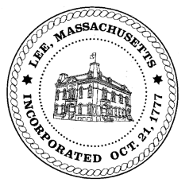
TOWN OF LEE
BOARD OF PUBLIC WORKS

Meeting Notice

Date: Tuesday, July 10, 2018 Time: 4:30 PM Place: 45 Railroad St., Lee

Agenda

Water
- Meter update
Highway/Cemetery
- Road Paving FY19
- Trucks/Sidewalk Plows
- Church Street Drainage/Baumann
Waste Water
- None
Other
- Abby Court Drainage
- Capacity Fees/Greylock St
Abatements
- Abatements
Approve Minutes from June 12 & 19, 2018 And any topic the chairman could not reasonably anticipate.
Next Board Meeting: July 24, 2018
BPW Members: Robert Bartini-Chairman, David Forrest-Clerk, Roger Scheurer, Peter Scolforo, Donald Zukowski, Jonathan Terry, Christopher Ketchen (Non Voting Member)

