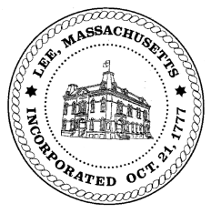
TOWN OF LEE
BOARD OF PUBLIC WORKS

Meeting Notice

Date: Tuesday, June 25, 2019 Time: 4:30 PM Place: 45 Railroad St., Lee

Agenda
Water
- Meter update
- 417 Chapel St (Barn)
Highway/Cemetery
- Paving
Waste Water
- 131 Paul Drive/sewer hook-up
Other
- Update 50 Columbia
- 650 Stockbridge Road – Capacity fee/water
- 589 West Road – Capacity fees
- 575 West Road – Capacity fees
Abatements
- 130 Housatonic/Ryel
Approve Minutes from May 28, 2019 And any topic the chairman could not reasonably anticipate.
Next Board Meeting July 9, 2019
BPW Members: Robert Bartini-Chairman, David Forrest-Clerk, Roger Scheurer, Peter Scolforo, Donald Zukowski,, Christopher Ketchen (Non Voting Member)

