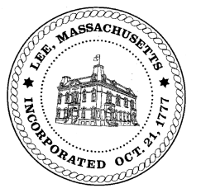
TOWN OF LEE
BOARD OF PUBLIC WORKS

Meeting Notice

Date: Tuesday, June 19, 2018 Time: 4:30 PM Place: 45 Railroad St., Lee
Agenda
Special
- Street Scan Presentation

And any topic the chairman could not reasonably anticipate.
Next Board Meeting: June 26, 2018
BPW Members: Robert Bartini-Chairman, David Forrest-Clerk, Roger Scheurer, Peter Scolforo, Donald Zukowski, Jonathan Terry, Christopher Ketchen (Non Voting Member)

