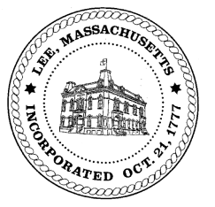
TOWN OF LEE
BOARD OF PUBLIC WORKS

Meeting Notice

Date: June 14, 2016 Time: 4:30 PM Place: 45 Railroad St., Lee

Agenda
Commitments
- May activity
Abatements
- Misc applications
- Cover sheet for abatements previously voted
Water
- Rate change discussion
Highway/Cemetery
- West Park St. Bridge
- Large Truck discussion
Waste Water
- Rate change discussion
Other
- Hot Rod software training

Approve Minutes from June 14, 2016.
And any topic the Chairman could not reasonably anticipate.
Next Board Meeting: July 28, 2016
BPW Members: Robert Bartini-Chairman, David Forrest-Clerk, Roger Scheurer, Peter Scolforo, Donald Zukowski, Jonathan Terry, and Robert Nason (Non-voting member)

