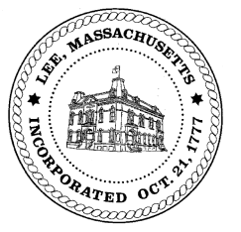
TOWN OF LEE
BOARD OF PUBLIC WORKS

Meeting Notice

Date: June 13, 2017 Time: 4:30 PM Place: 45 Railroad St., Lee

Agenda
Commitments
- Misc commitments
Abatements
- Misc abatements
Water
- Meter reader update
Highway/Cemetery
- Road Paving
Waste Water
- Laurel Street/Monica Ryan/Sewer Issue
Other
- None
Approve Minutes from May 23, 2017
And any topic the Chairman could not reasonably anticipate.

Next Board Meeting: June 27, 2017

BPW Members: Robert Bartini-Chairman, David Forrest-Clerk, Roger Scheurer, Peter Scolforo, Donald Zukowski, Jonathan Terry, and Robert Nason (Non-voting member)

