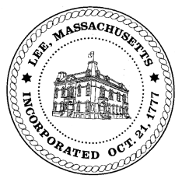
TOWN OF LEE
BOARD OF PUBLIC WORKS

Meeting Notice

Date: Tuesday, June 12, 2018 Time: 4:30 PM Place: 45 Railroad St., Lee
Agenda
Special
- Street Scan Presentation
Water
- Meter update
Highway/Cemetery
- Road Paving FY19
- Tips engineerying
- Trucks/Sidewalk Plows
- Bridge Repair
- Church Street Drainage/Baumann
- International Truck bid
Waste Water
- None
Other
- Abby Court Drainage- opening date
- Capacity Fees/Greylock St
- Department Staffing
Abatements
- Abatements
- Sign Commitments & Abatements
Approve Minutes from April 24, May 8 & May 22, 2018 And any topic the chairman could not reasonably anticipate.
Next Board Meeting: June 26, 2018
BPW Members: Robert Bartini-Chairman, David Forrest-Clerk, Roger Scheurer, Peter Scolforo, Donald Zukowski, Jonathan Terry, Christopher Ketchen (Non Voting Member)

