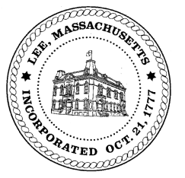
TOWN OF LEE
BOARD OF PUBLIC WORKS

Meeting Notice

Date: Wednesday, June 10, 2020 Time: 3:30 PM Place: 45 Railroad St., Lee

Water
- Meter update
- Water line update – Phase 1: Reservoir Road to Mill.
- Water shut offs 2020
Highway/Cemetery
- None
Waste Water
- Green Theory Cultivation – sewer discharge
Other
- Moe’s Tavern- sidewalk redesign
Abatements
- Signed Commits & Abates
Approve Minutes from March 10, 2020 And any topic the chairman could not reasonably anticipate.
Next Board Meeting: June 23, 2020
BPW Members: Robert Bartini-Chairman, David Forrest-Clerk, Roger Scheurer, Peter Scolforo, Donald Zukowski, Christopher Ketchen (Non Voting Member)

