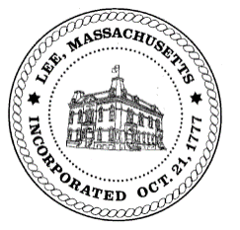**TOWN OF LEE**

**BOARD_OF PUBLIC WORKS**

***Meeting Notice***

**Date:** **Monday, June 12, 2023 Time:** 1:00 PM **Place:** 32 Main St, Town Hall Courtroom, Lee

* Call to Order
* Public Comment
* Accept Minutes of 5/8/2023

**Water Department**

* Robert St & Railroad St Water Main Replacement Discussion
  + Bid Results

**Highway/Cemetery Department**

* Town Mechanic Position
* Paving

**Waste Water Department**

**Capacity Permits**

* 160 High St

**Abatements**

* 35 Prospect St
* 175 George St
* 575 Devon Rd

**Any topic the chairman could not reasonably anticipate.**

**Other**

* Sign Approved Abatements
* Next Regular Meeting: June 26, 2023
* Motion to Adjourn

*BPW Members: Chairman Robert Bartini, Clerk David Forrest, Gary O’Brien, Robert Wright, Jim Ethier*