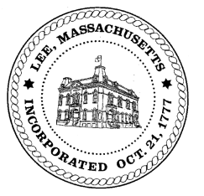
TOWN OF LEE
BOARD OF PUBLIC WORKS

Meeting Notice

Date: Tuesday, May 8, 2018 Time: 4:30 PM Place: 45 Railroad St., Lee
Agenda
Abatements
- Sign commitments & abatements
- Abatement
Water
- Meter update
Highway/Cemetery
- Road Paving
- Trucks/Sidewalk Plows
- Bridge Repair
- Street Scan
Waste Water
- None
Other
- Abby Court Drainage
- Capacity Fees/Greylock St
- Department Staffing
Approve Minutes from April 24, 2018 And any topic the Chairman could not reasonably anticipate.
Next Board Meeting: May 22, 2018
BPW Members: Robert Bartini-Chairman, David Forrest-Clerk, Roger Scheurer, Peter Scolforo, Donald Zukowski, Jonathan Terry, Christopher Ketchen (Non Voting Member)

