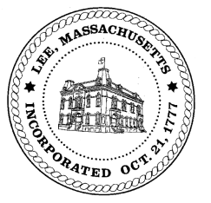
TOWN OF LEE
BOARD OF PUBLIC WORKS

Meeting Notice

Date: May 23, 2017 Time: 4:30 PM Place: 45 Railroad St., Lee

Agenda
Commitments
- Misc commitments
Abatements
- Misc abatement
Water
- Meter reader update

Highway/Cemetery
- None
Waste Water
- None
Other
- 4:30 - Chanterwood Road/SeWER – Matt Puntin SK Design
Approve Minutes from April 11, 2017& April 25, 2017
And any topic the Chairman could not reasonably anticipate.

Next Board Meeting: June 13, 2017

BPW Members: Robert Bartini-Chairman, David Forrest-Clerk, Roger Scheurer, Peter Scolforo, Donald Zukowski, Jonathan Terry, and Robert Nason (Non-voting member)

