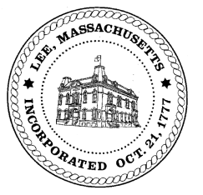
TOWN OF LEE
BOARD OF PUBLIC WORKS

Meeting Notice

Date: Wednesday, April 27, 2022 Time: 12:00 PM Place: 32 Main St, Courtroom, Lee

Water
- Meter update
- Open position
- ARPA funding – water line
Highway/Cemetery
- Future paving
- Capital/trucks
- Mt Everett truck
Waste Water
- Open position
Other
- Bullseye demo update
- Building Dept – capacity fees (Fox Hollow/Meadow Wood)
- 825 & 827 Mallard Lane capacity
- Sign commitments & abatements
- Tamarack brook area ditch cleaning
- 780 Greylock drainage proposal
And any topic the chairman could not reasonably anticipate.
Approve meeting minutes 3/24/22

BPW Members: Robert Bartini-Chairman, David Forrest-Clerk, Roger Scheurer, Peter Scolforo, Donald Zukowski, Gary O’Brien

