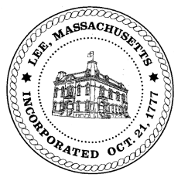
TOWN OF LEE
BOARD OF PUBLIC WORKS

Meeting Notice

Date: Tuesday, April 24, 2018 Time: 4:30 PM Place: 45 Railroad St., Lee
Agenda
Abatements
- Sign commitments & abatements
Water
- Meter update/communications
- Flushing
- Meter continuation during flushing
Highway/Cemetery
- Road Paving
- Trucks/Sidewalk Plows
- Bridge Repair
- Emergency repairs discussion
- Street Scan –awarded contract- access to information
- Budgeting engineering TIP funds versus paving funds
- Main Street engineering budget – separate line item?
Waste Water
- None
Other
- Abby Court Drainage
- Budgets
- Bid opening process
- Capacity Fees/Greylock St
- Fox Run
- Old truck advertising
- Department Staffing
Approve Minutes from April 10, 2018 And any topic the Chairman could not reasonably anticipate.
Next Board Meeting: May 8, 2018
BPW Members: Robert Bartini-Chairman, David Forrest-Clerk, Roger Scheurer, Peter Scolforo, Donald Zukowski, Jonathan Terry, Christopher Ketchen (Non Voting Member)

