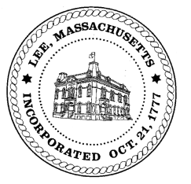
TOWN OF LEE
BOARD OF PUBLIC WORKS

Meeting Notice

Date: Tuesday, April 20, 2021 Time: 3:00 PM Place: 45 Railroad St., Lee

Water
- Meter update
Highway/Cemetery
- None
Waste Water
- None
Other
- Sign Abatements & Commitments
- Infrastructure work on Main Street
Abatements
- None

And any topic the chairman could not reasonably anticipate.

BPW Members: Robert Bartini-Chairman, David Forrest-Clerk (Non Voting Member), Roger Scheurer, Peter Scolforo, Donald Zukowski, Christopher Ketchen (Non Voting Member)

