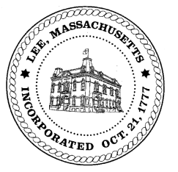
TOWN OF LEE
BOARD OF PUBLIC WORKS

Meeting Notice

Date: April 11, 2017 Time: 4:30 PM Place: 45 Railroad St., Lee

Agenda
Commitments
- Signing Commitments & Abatements
Abatements
- None
Water
- Meter reader update

Highway/Cemetery
- None
Waste Water
- Sewer tie in West/Devon Road – Rayner Warner
Other
- Cintas/Quarry Hill – 4:30
Approve Minutes from March 24, 2017
And any topic the Chairman could not reasonably anticipate.

Next Board Meeting: April 25, 2017

BPW Members: Robert Bartini-Chairman, David Forrest-Clerk, Roger Scheurer, Peter Scolforo, Donald Zukowski, Jonathan Terry, and Robert Nason (Non-voting member)

