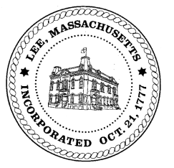
TOWN OF LEE
BOARD OF PUBLIC WORKS

Meeting Notice

Date: Monday, March 7, 2022 Time: 11:00 AM Place: 32 Main St, Courtroom, Lee

Water
- Meter update
- Open position
- ARPA funding – water line
- Robert Street water line
Highway/Cemetery
- Open position
- Future paving
- Capital/trucks
- Mt Everett truck
Waste Water
- Open position
Other
- Cemetery – special Town Meeting appropriation
- Bullseye demo update
- Building Dept – capacity fees (Fox Hollow/Meadow Wood)
Abatements
- 510 East Street – Dulin
- 325 Summer – Macioge
- 20 Laurel Ave - Farina

And any topic the chairman could not reasonably anticipate.
Approve meeting minutes 10/8/21 & 2/7/22

BPW Members: Robert Bartini-Chairman, David Forrest-Clerk, Roger Scheurer, Peter Scolforo, Donald Zukowski, Gary O’Brien

