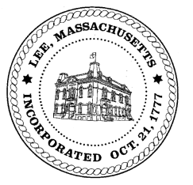
TOWN OF LEE
BOARD OF PUBLIC WORKS

Meeting Notice

Date: March 24, 2017 Time: 1:00 PM Place: 45 Railroad St., Lee

Agenda
Commitments
- Signing Commitments & Abatements
Abatements
- Misc abatement
Water
- Meter reader update

Highway/Cemetery
- None
Waste Water
- None
Other
- Capital Outlay & Budgets
- Solar panels – Eversource
- General DPW matters
Approve Minutes from January 10, 2017 & January 24, 2017
And any topic the Chairman could not reasonably anticipate.

Next Board Meeting: April 11, 2017

BPW Members: Robert Bartini-Chairman, David Forrest-Clerk, Roger Scheurer, Peter Scolforo, Donald Zukowski, Jonathan Terry, and Robert Nason (Non-voting member)

