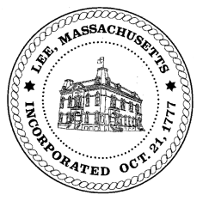
TOWN OF LEE
BOARD OF PUBLIC WORKS

Meeting Notice

Date: Tuesday, March 20, 2018 Time: 4:30 PM Place: 45 Railroad St., Lee

Agenda
Abatements
- Misc Abatements
- Sign Monthly Abatements & Commitments
Water
- Meter update
- Capacity Fees/Mallard Lane
- Capacity Fees/Greylock
Highway/Cemetery
- Road Paving
- Trucks/Sidewalk Plows
- Bridge Repair
- Emergency repairs bid awarding discussion
Waste Water
- None
Other
- Black Swan credit refund
- Capacity fees sign off/Devon Road
- Abby Court Drainage
- Budgets
- Bid opening process
Approve Minutes from February 14, 2018
And any topic the Chairman could not reasonably anticipate.
Next Board Meeting: April 10, 2018
BPW Members: Robert Bartini-Chairman, David Forrest-Clerk, Roger Scheurer, Peter Scolforo, Donald Zukowski, Jonathan Terry, Christopher Ketchen (Non Voting Member)

