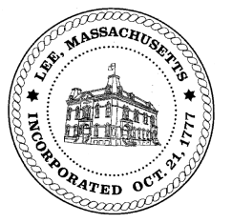
TOWN OF LEE
BOARD OF PUBLIC WORKS

Meeting Notice

Date: Tuesday, March 10, 2020 Time: 3:30 PM Place: 45 Railroad St., Lee

Water
- Meter update
- Water line update – Phase 1: Reservoir Road to Mill. Phase 2: Main Street
Highway/Cemetery
- Capital FY21
- Paving
Waste Water

Other
- Emergency Work ad
Abatements
- 1590 Pleasant Street
Approve Minutes from February 25, 2020 And any topic the chairman could not reasonably anticipate.
Next Board Meeting: March 24, 2020
BPW Members: Robert Bartini-Chairman, David Forrest-Clerk, Roger Scheurer, Peter Scolforo, Donald Zukowski, Christopher Ketchen (Non Voting Member)

