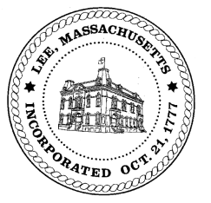
TOWN OF LEE
BOARD OF PUBLIC WORKS

Meeting Notice

Date: Monday, February 7, 2022 Time: 11:00 AM Place: 45 Railroad St., Lee

Water
- Meter update
- Open position
- ARPA funding – water line
- Capital
- Phase 1 waterline completion
Highway/Cemetery
- Capital
- Fleet/trucks/plows
Waste Water
- Open position
- Capital
Other
- Sign Abatements & Commitments
- Capacity fees (water & sewer)
- Capacity fees – 9 Paul Drive
- Cemetery
- 1035 Fairview curb cut – Ford
- Bullseye demo
Abatements
- 220 Summer Street -leak

And any topic the chairman could not reasonably anticipate.

BPW Members: Robert Bartini-Chairman, David Forrest-Clerk, Roger Scheurer, Peter Scolforo, Donald Zukowski, Gary O’Brien

