6
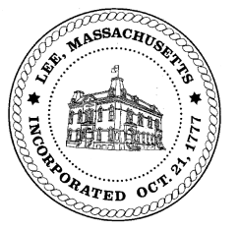
TOWN OF LEE
BOARD OF PUBLIC WORKS

Meeting Notice

Date: Tuesday, February 25, 2020 Time: 4:00 PM Place: 45 Railroad St., Lee

Water
- Meter update
- Water line update – Phase 1: Reservoir Road to Mill. Phase 2: Main Street
Highway/Cemetery
- Capital FY21
- Paving
Waste Water
- Relocation sewer line – Price Chopper property
Other
- 170 Prospect billing discussion
Abatements
- 100 Orchard Street abatement
Approve Minutes from February 11, 2020 And any topic the chairman could not reasonably anticipate.
Next Board Meeting: March 10, 2020
BPW Members: Robert Bartini-Chairman, David Forrest-Clerk, Roger Scheurer, Peter Scolforo, Donald Zukowski, Christopher Ketchen (Non Voting Member)

