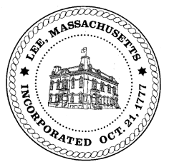
TOWN OF LEE
BOARD OF PUBLIC WORKS

Meeting Notice

Date: Tuesday, February 12, 2019 Time: 4:30 PM Place: 45 Railroad St., Lee

CANCELLED DUE TO WEATHER
Agenda

Water
- Meter update
- Water usuage
Highway/Cemetery
- New sidewalk plow
Waste Water
- None
Other
- High Lawn Farm/further discussion/February
- Property at 50 Columbia/drainage
Abatements
- Sign Commits & Abatements
Approve Minutes from January 22, 2019 And any topic the chairman could not reasonably anticipate.
Next Board Meeting February 26, 2019
BPW Members: Robert Bartini-Chairman, David Forrest-Clerk, Roger Scheurer, Peter Scolforo, Donald Zukowski,, Christopher Ketchen (Non Voting Member)

