6
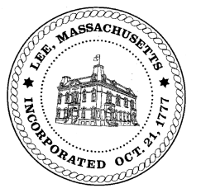
TOWN OF LEE
BOARD OF PUBLIC WORKS

Meeting Notice

Date: Tuesday, February 11, 2020 Time: 4:00 PM Place: 45 Railroad St., Lee

Water
- Meter update
- Water line update – Phase 1: Reservoir Road to Mill. Phase 2: Main Street
Highway/Cemetery
- None
Waste Water
- None
Other
- 170 Prospect discussion
- 195 Spring Street – water capacity fee & curb cut –Bullock
- Canna Provisions –Quarry Hill – request relocate sewer line
- East Street curb cut – Leprovost
- Sign abatements & committments
Abatements
- 100 Orchard Street abatement
- 82 Railroad Street – Kelly- discussion

- 90 St James – Boomsma – pool
- 26 East Center - Lloyd
Approve Minutes from January 14, 2020 And any topic the chairman could not reasonably anticipate.
Next Board Meeting: February 25, 2020
BPW Members: Robert Bartini-Chairman, David Forrest-Clerk, Roger Scheurer, Peter Scolforo, Donald Zukowski, Christopher Ketchen (Non Voting Member)

