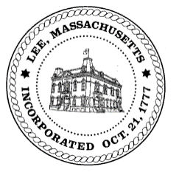
TOWN OF LEE
BOARD_OF PUBLIC WORKS

Meeting Notice

Date: Tuesday, February 28, 2023 Time: 12:00 PM Place: 32 Main St, Town Hall Courtroom, Lee

Water
- Meter Reading/Billing Update
- Capital Purchases
- Railroad St & Robert St Update

Highway/Cemetery
- Capital Purchases
- Excavator Accessories
- Ranger Sale Update
- Equipment Sales Spring 2023
- Cemetery Policies
- Cemetery Regulation Signs
- Cemetery Mower

Waste Water
- Capital Purchases
- New Municipal Building Location

Abatements
- High Lawn Farm
- 145 Via Maria (Locke)
- 25 Prospect St (McGuire)
- 301 E. Center St (Arnold)
- 1530 Pleasant St (Marian Missionaries)
- 1545 Pleasant St (Marian Missionaries)

Capacity Permits
- 45 Erskine Drive

Other
- Accept Minutes from meeting on January 24, 2023
- Sign Commitments
- Adjourn Meeting

And any topic the chairman could not reasonably anticipate.

BPW Members: Chairman Robert Bartini, Clerk David Forrest, Gary O’Brien, Robert Wright, Jim Ethier

