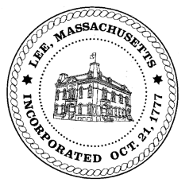
TOWN OF LEE
BOARD OF PUBLIC WORKS

Meeting Notice

Date: January 9, 2018 Time: 4:30 PM Place: 45 Railroad St., Lee

Agenda
Abatements
- None
Water
- Meter update
Highway/Cemetery
- Road Paving
- Trucks
Waste Water
- Capacity 785 Pleasant Street
Other
- Capacity fees – Greylock St
- Capacity fees – Mallard Lane
- Road condition reports
Approve Minutes from December 26, 2017
And any topic the Chairman could not reasonably anticipate.

Next Board Meeting: January 23, 2018

BPW Members: Robert Bartini-Chairman, David Forrest-Clerk, Roger Scheurer, Peter Scolforo, Donald Zukowski, Jonathan Terry, Christopher Ketchen (Non Voting Member)

