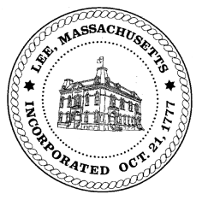
TOWN OF LEE
BOARD OF PUBLIC WORKS

Meeting Notice

Date: Tuesday, January 8, 2018 Time: 4:30 PM Place: 45 Railroad St., Lee

Agenda
MEETING CANCELLED LACK OF AGENDA ITEMS

Water
- Meter update
Highway/Cemetery
- Road Paving FY19
- Trucks
- Equipment for FY20
Waste Water
- None
Other
- High Lawn Farm/further discussion/January
- Main Street redo
- TIP engineering
- 690 Greylock Street driveway/Forrest
Abatements
- Cecil Pollen follow up
Approve Minutes from December 11, 2018 And any topic the chairman could not reasonably anticipate.
Next Board Meeting January 22, 2019
BPW Members: Robert Bartini-Chairman, David Forrest-Clerk, Roger Scheurer, Peter Scolforo, Donald Zukowski,, Christopher Ketchen (Non Voting Member)

