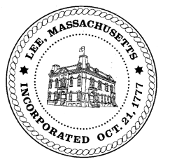
TOWN OF LEE
BOARD OF PUBLIC WORKS

Meeting Notice

Date: January 23, 2018 Time: 4:30 PM Place: 45 Railroad St., Lee

Agenda
Abatements
- None
Water
- Meter update
Highway/Cemetery
- Road Paving
- Trucks
- Bridge Repair
Waste Water
- None
Other
- Main Street Project/Foresight
Approve Minutes from January 9, 2018
And any topic the Chairman could not reasonably anticipate.

Next Board Meeting: February 13, 2018

BPW Members: Robert Bartini-Chairman, David Forrest-Clerk, Roger Scheurer, Peter Scolforo, Donald Zukowski, Jonathan Terry, Christopher Ketchen (Non Voting Member)

