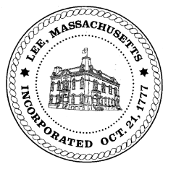
TOWN OF LEE
BOARD OF PUBLIC WORKS

Meeting Notice

Date: Tuesday, January 14, 2020 Time: 2:30 PM Place: 45 Railroad St., Lee

Water
- Meter update
- Update Eagle Mill waterline
- Update Main Street waterline
Highway/Cemetery
- None
Waste Water
- None
Other
- 170 Prospect discussion
- Capital requests DPW
Abatements
- 100 Orchard Street abatement
- Sign Abatements & Commitments
- 905 Pleasant Street abatement

Approve Minutes from December 3, 2019 And any topic the chairman could not reasonably anticipate.
Next Board Meeting: January 28, 2020
BPW Members: Robert Bartini-Chairman, David Forrest-Clerk, Roger Scheurer, Peter Scolforo, Donald Zukowski, Christopher Ketchen (Non Voting Member)

