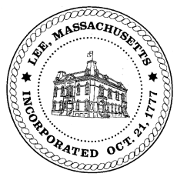
TOWN OF LEE
BOARD OF PUBLIC WORKS

Meeting Notice

Date: January 10, 2017 Time: 4:30 PM Place: 45 Railroad St., Lee

Agenda
Commitments
- 3rd Quarter Commitments
Abatements
- Misc Abatements
Water
- Plant update
Highway/Cemetery
- None
Waste Water
- None
Other
- None
Approve Minutes from November 22, 2016
And any topic the Chairman could not reasonably anticipate.

Next Board Meeting: January 24, 2017

BPW Members: Robert Bartini-Chairman, David Forrest-Clerk, Roger Scheurer, Peter Scolforo, Donald Zukowski, Jonathan Terry, and Robert Nason (Non-voting member)

