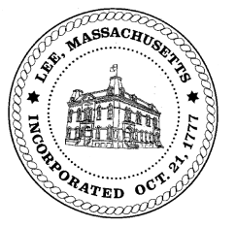
TOWN OF LEE
BOARD OF PUBLIC WORKS

Meeting Notice

Date: Tuesday, December 3, 2019 Time: 11:00 AM Place: 45 Railroad St., Lee

Water
- Meter update
Highway/Cemetery
- Winter plowing position
Waste Water
- None
Other
- 50 Columbia - drainage
Abatements
- None

Approve Minutes from November 12, 2019 And any topic the chairman could not reasonably anticipate.
Next Board Meeting: December 10, 2019
BPW Members: Robert Bartini-Chairman, David Forrest-Clerk, Roger Scheurer, Peter Scolforo, Donald Zukowski, Christopher Ketchen (Non Voting Member)

