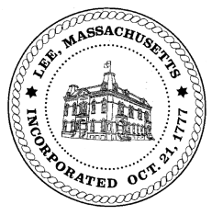
TOWN OF LEE
BOARD OF PUBLIC WORKS

Meeting Notice

Date: December 26, 2017 Time: 4:30 PM Place: 45 Railroad St., Lee

Agenda
Abatements
- Misc Abatement
Water
- Meter update
Highway/Cemetery
- Road Paving
- Trucks
Waste Water
- Capacity 785 Pleasant Street
Other
- Street Scan presentation
- Capacity fees – Greylock St
Approve Minutes from December 12, 2017
And any topic the Chairman could not reasonably anticipate.

Next Board Meeting: January 9, 2018

BPW Members: Robert Bartini-Chairman, David Forrest-Clerk, Roger Scheurer, Peter Scolforo, Donald Zukowski, Jonathan Terry, Christopher Ketchen (Non Voting Member)

