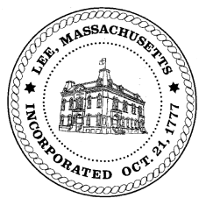
TOWN OF LEE
BOARD OF PUBLIC WORKS

Meeting Notice

Date: Tuesday, December 11, 2018 Time: 4:30 PM Place: 45 Railroad St., Lee

Agenda

Water
- Meter update
Highway/Cemetery
- Road Paving FY19
- Sidewalk plow delivered
- Trucks
- Equipment for FY20
Waste Water
- None
Other
- High Lawn Farm/further discussion/January
- Main Street redo
- TIP engineering
Abatements
- None
Approve Minutes from November 27, 2018 And any topic the chairman could not reasonably anticipate.
Next Board Meeting January 8, 2019
BPW Members: Robert Bartini-Chairman, David Forrest-Clerk, Roger Scheurer, Peter Scolforo, Donald Zukowski,, Christopher Ketchen (Non Voting Member)

