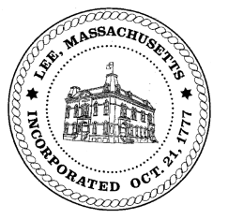
TOWN OF LEE
BOARD OF PUBLIC WORKS

Meeting Notice

Date: November 8, 2016 Time: 4:30 PM Place: 45 Railroad St., Lee

Agenda
Commitments
- September Commitments
Abatements
- Water/Sewer Regulations posting
- Misc Abatement
Water
- Meter Readers
Highway/Cemetery
- Crosswalks
- Forest Street
- Drainage in Abey Court
- High Lawn Farms Driveways
- Coves on Columbia & Old Columbia
- New Truck
- Sister Trucks
Waste Water
- None
Other
- Communications to the Board
Approve Minutes from October 25, 2016
And any topic the Chairman could not reasonably anticipate.
Next Board Meeting: November 22, 2016
BPW Members: Robert Bartini-Chairman, David Forrest-Clerk, Roger Scheurer, Peter Scolforo, Donald Zukowski, Jonathan Terry, and Robert Nason (Non-voting member)

