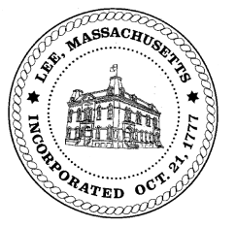
TOWN OF LEE
BOARD OF PUBLIC WORKS

Meeting Notice

Date: Tuesday, November 27, 2018 Time: 4:30 PM Place: 45 Railroad St., Lee

Agenda

Water
- Meter update
- Mass Grant
Highway/Cemetery
- Road Paving FY19
- Sidewalk plow delivery update
Waste Water
- None
Other
- High Lawn Farm
- Main Street redo
- TIP engineering update
- Building Department
Abatements
- Abatement – Pollen
- Abatement - Leprovost
Approve Minutes from October 13, 2018 And any topic the chairman could not reasonably anticipate.
Next Board Meeting December 11, 2018
BPW Members: Robert Bartini-Chairman, David Forrest-Clerk, Roger Scheurer, Peter Scolforo, Donald Zukowski,, Christopher Ketchen (Non Voting Member)

