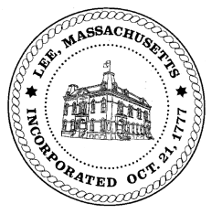
TOWN OF LEE
BOARD OF PUBLIC WORKS

Meeting Notice

Date: November 22, 2016 Time: 4:30 PM Place: 45 Railroad St., Lee

Agenda
Commitments
- September Commitments
Abatements
- Misc Abatements
- Abatement Application revisions
Water
- Meter Readers
Highway/Cemetery
- Crosswalks
- High Lawn Farms Driveways
- Coves on Columbia & Old Columbia
- New Trucks
Waste Water
- None
Other
- Public Hearing for proposed water/sewer regulation revisions
Approve Minutes from October 25, 2016 & November 8, 2016
And any topic the Chairman could not reasonably anticipate.
Next Board Meeting: December 13, 2016
BPW Members: Robert Bartini-Chairman, David Forrest-Clerk, Roger Scheurer, Peter Scolforo, Donald Zukowski, Jonathan Terry, and Robert Nason (Non-voting member)

