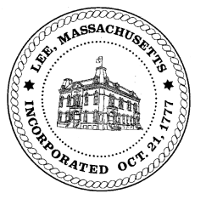
TOWN OF LEE
BOARD OF PUBLIC WORKS

Meeting Notice

Date: November 14, 2017 Time: 4:30 PM Place: 45 Railroad St., Lee

Agenda
Abatements
- Misc Abatement
Water
- Regulations for meter inspection on installation
- Meter update
Highway/Cemetery
- Road Paving
- Trucks
Waste Water
- 785 Pleasant St/Diller
Other
- Capacity fees – Greylock St
- Capacity fees – Marble Street
- Quarterly Committments
Approve Minutes from October 10, 2017
And any topic the Chairman could not reasonably anticipate.

Next Board Meeting: November 28, 2017

BPW Members: Robert Bartini-Chairman, David Forrest-Clerk, Roger Scheurer, Peter Scolforo, Donald Zukowski, Jonathan Terry, Christopher Ketchen (Non Voting Member)

