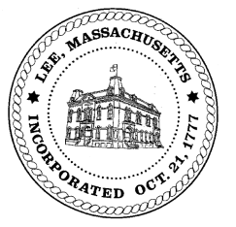
TOWN OF LEE
BOARD OF PUBLIC WORKS

Meeting Notice

Date: Tuesday, November 13, 2018 Time: 4:30 PM Place: 45 Railroad St., Lee

Agenda

Water
- Meter update
- Mass Grant
Highway/Cemetery
- Road Paving FY19
Waste Water
- None
Other
- SK Design presentation – Eagle Mill
- Meadow Wood
- High Lawn Farm
Abatements
- Abatements - Pollen
- Commitments/Abatements
Approve Minutes from October 23, 2018 And any topic the chairman could not reasonably anticipate.
Next Board Meeting November 27, 2018
BPW Members: Robert Bartini-Chairman, David Forrest-Clerk, Roger Scheurer, Peter Scolforo, Donald Zukowski,, Christopher Ketchen (Non Voting Member)

