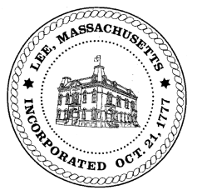
TOWN OF LEE
BOARD OF PUBLIC WORKS

Meeting Notice

Date: Tuesday, November 12, 2019 Time: 3:00 PM Place: 45 Railroad St., Lee

Agenda
Water
- Meter update
- Flushing times
Highway/Cemetery
- Paving – Maple Street update
- Winter plowing position
Waste Water
- None
Other
- Tamarack Brook update
- Temporary Drive – 170 Maple – Zabian
- 1% tax infrastructure discussion
- Green Theory Cultivation discussion
Abatements
- 90 Via Maria/Pool liner

Approve Minutes from September 24, 2019 And any topic the chairman could not reasonably anticipate.
Next Board Meeting ;
November 25,, 2019
BPW Members: Robert Bartini-Chairman, David Forrest-Clerk, Roger Scheurer, Peter Scolforo, Donald Zukowski,, Christopher Ketchen (Non Voting Member)

