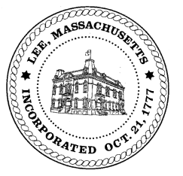
TOWN OF LEE
BOARD OF PUBLIC WORKS

Meeting Notice

Date: Tuesday, October 23, 2018 Time: 4:30 PM Place: 45 Railroad St., Lee

Agenda

Water
- Meter update
Highway/Cemetery
- Road Paving FY19
- Sidewalk machine
Waste Water
- None
Other
- Meadow Wood/High Lawn
- Capacity fees 850 Summer Street
- Abatement Policy review
Abatements
- Abatements
- Commitments
Approve Minutes from September 25, 2018 And any topic the chairman could not reasonably anticipate.
Next Board Meeting November 13, 2018
BPW Members: Robert Bartini-Chairman, David Forrest-Clerk, Roger Scheurer, Peter Scolforo, Donald Zukowski,, Christopher Ketchen (Non Voting Member)

