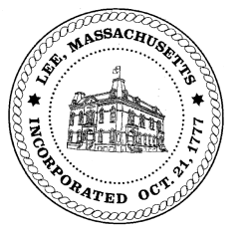
TOWN OF LEE
BOARD OF PUBLIC WORKS

Meeting Notice

Date: October 16, 2017 Time: 4:30 PM Place: 45 Railroad St., Lee

Agenda
Abatements
- Mallard Lane
- Mill Street
- Maple Street/Doscher
- Misc abatement
Water
- Regulations for meter inspection on installation
Highway/Cemetery
- Road Paving
- Trucks
Waste Water
- 705 Marble/capacity
Other
- 690 Greylock/curb cut

Approve Minutes from September 26, 2017
And any topic the Chairman could not reasonably anticipate.

Next Board Meeting: October 24, 2017

BPW Members: Robert Bartini-Chairman, David Forrest-Clerk, Roger Scheurer, Peter Scolforo, Donald Zukowski, Jonathan Terry, Christopher Ketchen (Non Voting Member)

